# TRUMP’S TAX BILL GAVE HUGE HANDOUTS TO BIG TECH

|  |
| --- |
| **SUMMARY**   * **The tax bill extended an R&D credit that primarily benefited Big Tech.** The bill restored the ability for businesses to immediately deduct 100% of their domestic R&D expenses. Big Tech trade groups and companies, including the Information Technology & Innovation Foundation, the Business Software Alliance, and the Information Technology Industry Council, lobbied for Congress to bring back full R&D expensing. Alphabet, Amazon, Apple, Meta, and Tesla were projected to win $75 billion in tax breaks with the R&D deduction restored. Alphabet would be the single biggest beneficiary of the deduction, reaping $9.4 billion. * **Big Tech companies benefited from the tax bill’s permanent extension of 100% bonus depreciation.** Large, already profitable firms were the main beneficiaries of the bonus depreciation tax credit. * **Big Tech companies benefited from the tax bill’s adjustments to how the business interest deduction was calculated.** The bill restored and made permanent more generous limits on business interest deductions. * **Big Tech companies benefited from the tax bill’s protection of the 21% corporate tax rate.** Trade groups that included Big Tech companies like the National Retail Federation and the Information Technology Industry Council had pushed for Congress to keep the corporate tax rate low. * **The tax bill expanded the foreign-derived intangible income (FDII) and global intangible low-taxed income (GILTI) deductions, which largely benefited Big Tech companies.** The FDII and GILTI effective tax rates were set to rise in 2026, but the new bill extended the lower rates permanently.   + The FDII deduction was a huge tax break for corporations that earn income from their intellectual property by selling goods abroad, like Big Tech. FDII was a major reason why Big Tech firms paid so much less than the statutory corporate tax rate. Alphabet has been the single largest beneficiary of the FDII deduction since 2018, reporting $11 billion in tax breaks, while Amazon also reported $1 billion in tax breaks. Big Tech trade groups have pushed for the protection of the FDII deduction.   + Big Tech trade groups also pushed for Congress not to raise the GILTI tax rate, which aims at income earned from “intangible assets” like IP. * **The tax bill reduced the Base Erosion and Anti-Abuse Tax (BEAT), a key priority for Big Tech.** BEAT was designed to curb artificial profit shifting arrangements. Big Tech lobbying groups like the Information Technology Innovation Council pushed for BEAT to be reduced, calling it a punishment for R&D costs. * **Big Tech companies stood to gain from the massive amounts of new funding for ICE in the tax bill.** The bill more than tripled the budget for Customs and Border Protection to more than $60 billion, which will likely result in bigger contracts to surveillance tech companies. Amazon has received major government contracts from ICE for its cloud services platform. Palantir paid Amazon $600,000 a month for the use of its servers for the case management system used by ICE. |

## THE TAX BILL EXTENDED AN R&D TAX CREDIT THAT PRIMARILY BENEFITED BIG TECH

### THE TAX BILL EXTENDED A CREDIT ALLOWING FOR FULL IMMEDIATE EXPENSING FOR DOMESTIC R&D

**The Senate Bill Would Permanently Allow Full Immediate Expensing For Domestic Research And Development.** 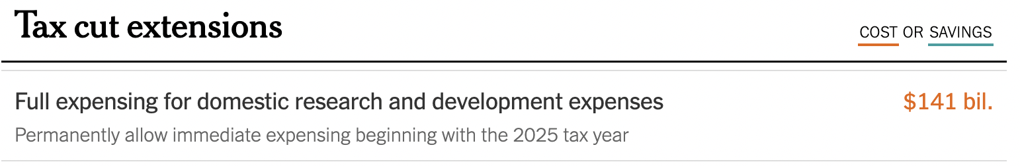

[New York Times, [6/30/2025](https://www.nytimes.com/interactive/2025/06/30/upshot/senate-republican-megabill.html)]

**The Big Beautiful Bill Included A Provision To Restore The Ability For Businesses To Immediately Deduct 100% Of Their Domestic R&D Expenses.** “The sweeping tax bill passed by House Republicans, H.R. 1, the ‘One Big Beautiful Bill Act,’ includes a provision that would temporarily restore the ability for businesses to immediately deduct 100% of their domestic R&D expenses. If enacted, Section 111002 of the bill would let firms expense 100% of domestic R&D expenses from January 19, 2025, through 2029. The move would reverse a change implemented in 2022 that required companies to amortize these costs over five years. Reversing that policy would provide immediate tax relief for companies investing heavily in R&D. However, the landscape varies dramatically by sector.” [R&D World, [5/30/2025](https://www.rdworldonline.com/big-beautiful-bill-act-proposes-restoring-full-rd-expensing-for-2025-2029/)]

### THE R&D TAX CREDIT WAS A HANDOUT TO BIG TECH

##### WHEN THE R&D TAX WRITE OFF WAS PREVIOUSLY ROLLED BACK IN 2022, BIG TECH COMPANIES BEGAN MASS LAYOFFS

**In 2022, The R&D Expensing Tax Cut Changed To No Longer Be A Full, Immediate Write-Off.** “And so, on schedule in 2022, the change to Section 174 went into effect. Companies filed their 2022 tax returns under the new rules in early 2023. And suddenly, R&D wasn’t a full, immediate write-off anymore. The tax benefits of salaries for engineers, product and project managers, data scientists, and even some user experience and marketing staff — all of which had previously reduced taxable income in year one — now had to be spread out over five- or 15-year periods.” [Quartz, [6/4/2025](https://qz.com/tech-layoffs-tax-code-trump-section-174-microsoft-meta-1851783502)]

**Immediately After The R&D Tax Cut Change Took Effect, Meta, Google, And Amazon Began Mass Layoffs.** “It’s no coincidence that Meta announced its ‘Year of Efficiency’ immediately after the Section 174 change took effect. Ditto Microsoft laying off 10,000 employees in January 2023 despite strong earnings, or Google parent Alphabet cutting 12,000 jobs around the same time. Amazon (AMZN) also laid off almost 30,000 people, with cuts focused not just on logistics but on Alexa and internal cloud tools — precisely the kinds of projects that would have once qualified as immediately deductible R&D. Salesforce (CRM) eliminated 10% of its staff, or 8,000 people, including entire product teams.” [Quartz, [6/4/2025](https://qz.com/tech-layoffs-tax-code-trump-section-174-microsoft-meta-1851783502)]

**Salaries Were Meta’s Single Biggest R&D Expense, And The Company Cut Its Overall Workforce By Almost 25%.** “In its 2023 annual report, Meta described salaries as its single biggest R&D expense. Between the first and second years that the Section 174 change began affecting tax returns, Meta cut its total workforce by almost 25%. Over the same period, Microsoft reduced its global headcount by about 7%, with cuts concentrated in product-facing, engineering-heavy roles.” [Quartz, [6/4/2025](https://qz.com/tech-layoffs-tax-code-trump-section-174-microsoft-meta-1851783502)]

##### BIG TECH TRADE GROUPS AND COMPANIES LOBBIED FOR CONGRESS TO BRING BACK FULL R&D EXPENSING

**The Information Technology & Innovation Foundation Pushed For Congress To Bring Back Full R&D Expensing.** “Investments in research and development drive innovation, growth, and competitiveness. Moreover, the lion’s share of the benefits from these investments accrues to society, not to individual firms, so tax incentives that encourage such expenditures serve as an important public good. Yet the tax provision allowing firms to fully expense their research and development (R&D) costs in the year of investment expired at the end of 2021, decreasing firms’ incentive to invest in this key driver of economic growth and competitiveness. Indeed, data from the National Science Foundation shows that the business sector’s annual increase in R&D investment since the expiration of full R&D expensing is only a fraction of what it was beforehand. Congress should pass the American Innovation and R&D Competitiveness Act of 2025 to restore the immediate deductibility of R&D expenses.” [Information Technology & Innovation Foundation, [5/28/2025](https://itif.org/publications/2025/05/28/rd-investment-is-slipping-bring-back-full-rd-expensing/)]

* **The Information Technology And Innovation Foundation Was Sponsored By Alphabet, Amazon, Apple, And Meta.** [Information Technology & Innovation Foundation, accessed [7/2/2025](https://itif.org/our-supporters/)]

**The Business Software Alliance Supported The R&D Tax Credit.** “Business Software Alliance Senior Director, Legislative Strategy Bruce Miller issued the following statement on the Senate Finance Committee's proposal on an R&D tax credit: ‘The Business Software Alliance (BSA) welcomes the Senate Finance Committee’s proposal to restore and make permanent the R&D tax credit and allow full and immediate expensing of R&D costs. This provision helps to enable the enterprise software industry’s investments into artificial intelligence and breakthrough technologies like quantum computing. Information and software R&D account for a quarter of total US R&D spending, and realizing the goal of American technological leadership requires sustained R&D and keeping the United States the top destination for innovation investment.’” [Business Software Alliance, [6/17/2025](https://www.bsa.org/news-events/news/bsa-supports-rd-tax-credit)]

* **Amazon Was A Member Of The Business Software Alliance.** [Business Software Alliance, accessed [9/7/22](https://www.bsa.org/membership)]

**The Information Technology Industry Council Released A Statement Saying It Appreciated Lawmakers “Heeding Industry’s Call To Action” And Permanently Restoring R&D Expensing.** “Today, global tech trade association ITI released the following statement from its President and CEO Jason Oxman following the release of the U.S. Senate Finance Committee’s budget reconciliation text, which includes several pro-growth tax provisions. ‘We’re pleased to see the U.S. Senate build off the House-passed reconciliation package with strong language that will cement the United States’ position as the world’s leader in technology, boost the U.S. semiconductor ecosystem, and bolster the international tax regime. We appreciate lawmakers heeding industry’s call to action and creating a permanent extension for restoring research and development (R&D) expensing that will keep AI innovation on U.S. soil, enable U.S. companies to invest in America and create high-skilled jobs, and make the U.S. more competitive. We look forward to working with Members of Congress to get this legislation over the finish line and onto President Trump’s desk for signature.’” [Information Technology Industry Council, [6/16/2025](https://www.itic.org/news-events/news-releases/iti-senate-finance-reconciliation-text-will-enhance-u-s-tech-competitiveness)]

* **The Information Technology Industry Council’s Members Included Amazon, Apple, Google, And Meta.** [Information Technology Industry Council, accessed [8/11/22](https://www.itic.org/about/membership/iti-members)]

**Restoring The R&D Expensing Policy Was A Key Tax Priority For The Information Technology Industry Council For 2025.** “Today, global tech trade association ITI sent a new letter to U.S. House Ways and Means Committee Chairman Jason Smith (R-MO) and other members of Congressional leadership outlining key tax policies that impact U.S. innovation, global competitiveness and leadership, and U.S. economic growth and job creation. ‘By addressing these critical tax policies, Congress can foster an environment that promotes innovation, protects U.S. economic interests, and ensures that the United States continues to lead in the global technology landscape,’ wrote ITI President and CEO Jason Oxman in the letter. ITI recommends that lawmakers focus on these priority U.S. tax policies: Restoring the ability to deduct research and development (R&D) expenses in the current year, which would drive future innovation and economic growth and benefit American workers, businesses, and communities.” [Information Technology Industry Council, [10/15/2024](https://www.itic.org/news-events/news-releases/iti-outlines-2025-tax-priorities-to-congressional-leadership)]

**Alphabet, Amazon, Apple, Meta, And Tesla Spent Over $63 Million Lobbying For Tax Breaks Including Retroactive And Immediate R&D Expensing.** “Nevertheless, even as your R&D investments have increased since R&D expensing ended, Tesla has lobbied to bring back this corporate tax break and find other ways to slash your tax bill even lower. You are a member of a number of organizations that are intensely lobbying for the retroactive application and extension of R&D expensing, including the Chamber of Commerce.9 Just last year, Alphabet, Amazon, Apple, Meta, and Tesla spent over $63 million lobbying for tax breaks that include retroactive and immediate R&D expensing.10 To cozy up with your benefactors, you even donated $288 million to President Trump’s campaign and personally attended the inauguration, in an attempt to buy favor as President Trump and Congressional Republicans develop their plans to cut taxes for billionaires and billionaire corporations this year.11” [Senator Elizabeth Warren, [3/5/2025](https://www.warren.senate.gov/imo/media/doc/warren_to_big_tech_ceos_re_rd_expensing.pdf)]

##### BIG TECH COMPANIES STOOD TO GAIN MASSIVELY FROM THE R&D EXPENSING TAX BREAK

**In A Letter To Big Tech CEOs, Sen. Elizabeth Warren Said That Big Tech Companies Stood To Gain Massively From The Bill’s Retroactive R&D Expensing Tax Break.** “Your company stands to gain massively from the retroactive R&D expensing tax break in Senate Republicans’ bill. The legislation would allow businesses to immediately deduct the cost of R&D expenses, rather than deducting those costs over several years.4 However, rather than merely allowing immediate R&D expensing for future tax years, the bill would allow all companies to immediately write off the entirety of any unamortized R&D expenses incurred during previous tax years since 2022 — in Alphabet’s case, billions of dollars — immensely slashing your overall tax liability.5 Since even the proponents of R&D expensing argue that the policy’s purpose is to incentivize future R&D spending,6 this retroactive tax break for previous years’ R&D spending is an utterly pointless and brazenly irresponsible corporate handout.” [Senator Elizabeth Warren, [6/30/2025](https://www.warren.senate.gov/imo/media/doc/letter_to_big_tech_ceos.pdf)]

**Alphabet, Amazon, Apple, Meta, And Tesla Could Win $75 Billion In Tax Breaks If The R&D Deduction Was Restored.** “New financial reports indicate five of America’s biggest corporations—Alphabet, Amazon, Apple, Meta, and Tesla—could win $75 billion in tax breaks if Congress and the President satisfy demands from corporate lobbyists to reinstate a provision repealed under the 2017 Trump tax law. The CEOs of these companies may have hoped to gain any number of benefits from attending the second inauguration of President Trump in January, and this tax break is just one possible example. The tax break allowed companies to immediately deduct the expenses characterized as research and development in the year they are incurred rather than deducting those expenses over several years like other investments. Repeal of this tax break was one of the few revenue-raising provisions in the Trump tax law and it was supposed to slightly offset the costs of the law’s corporate tax cuts. The Trump tax law repealed the R&D expensing break starting in 2022, replacing it with a less generous rule requiring R&D expenses to be deducted over five years. In the previous Congress, the House of Representatives passed a bill reinstating the break retroactive to 2022. That bill did not advance in the Senate, but now that Republicans control the House, Senate, and White House, there is every reason to believe the proposal will be considered again.” [Institute on Taxation and Economic Policy, [2/11/2025](https://itep.org/alphabet-amazon-apple-meta-tesla-corporate-tax-cuts-trump-tax-law/)]

**Alphabet Was Projected To Be The Single Biggest Beneficiary Of The R&D Tax Deduction,   
Reaping $9.4 Billion.**

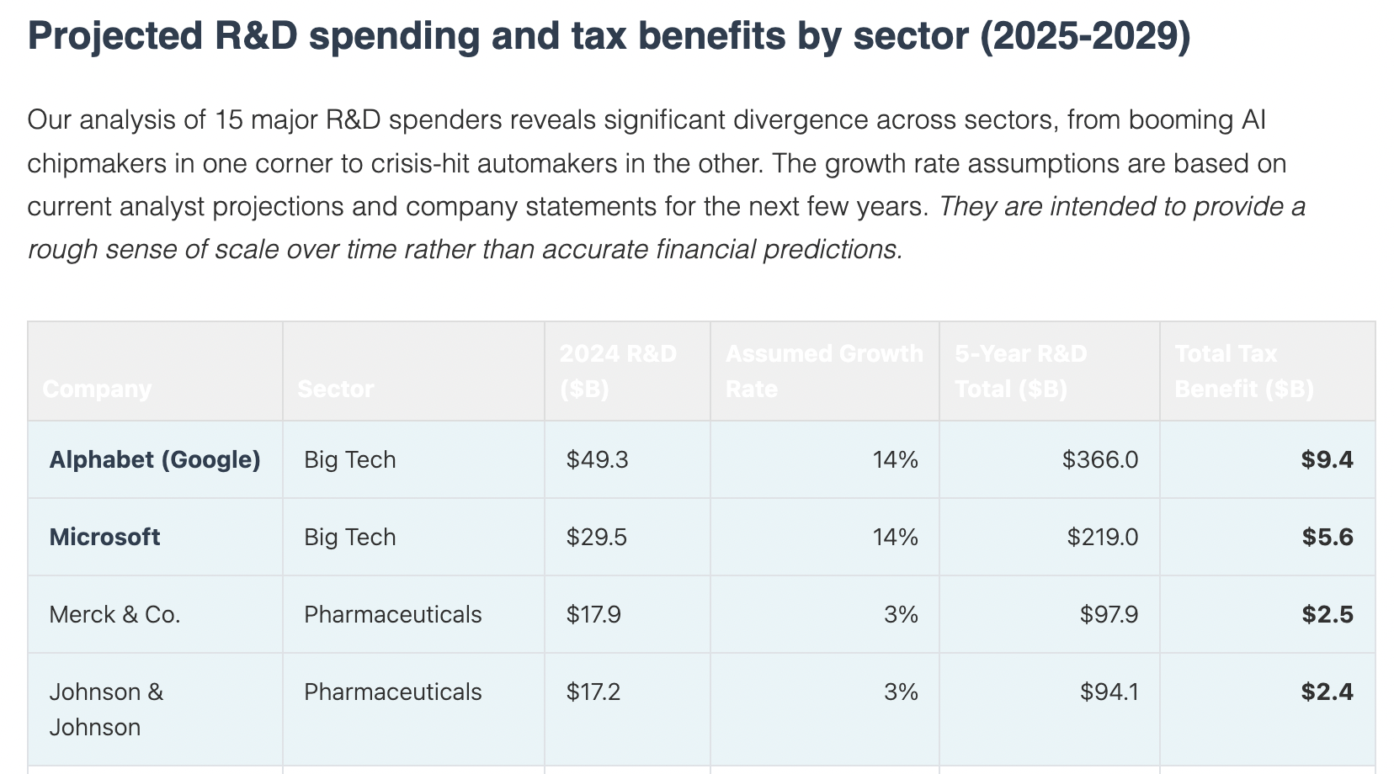

[R&D World, [5/30/2025](https://www.rdworldonline.com/big-beautiful-bill-act-proposes-restoring-full-rd-expensing-for-2025-2029/)]

## BIG TECH COMPANIES BENEFITED FROM THE TAX BILL’S PERMANENT EXTENSION OF 100% BONUS DEPRECIATION

**Big Tech Companies Would Benefit Financially From The Tax Bill’s Permanent Extension Of 100% Bonus Depreciation.** “Second, in addition to benefiting from this retroactive tax break, Alphabet will also benefit financially from the tax bill’s permanent extension of 100% bonus depreciation, which will permit your company to immediately write off the entire cost of purchasing equipment or other assets.10 This policy disproportionately benefits giant corporations while providing little help for small businesses.11” [Senator Elizabeth Warren, [6/30/2025](https://www.warren.senate.gov/imo/media/doc/letter_to_big_tech_ceos.pdf)]

##### LARGE, ALREADY PROFITABLE FIRMS WERE THE MAIN BENEFICIARIES OF THE BONUS DEPRECIATION TAX CREDIT

**Already Profitable Firms Were The Most Likely Users Of The Bonus Depreciation Tax Break.** “Large firms invest a lot and some suggest they would be the primary beneficiaries of extending bonus depreciation. But Congress seems deeply conflicted about this potential windfall. Its concerns about large corporations not paying enough taxes led to passage this year of the new book minimum tax on large companies. Yet Congress excluded depreciation from the minimum tax, worried it would discourage investment. Not all firms take advantage of bonus depreciation. TPC and Treasury research finds that already profitable firms are the most likely users. This could reduce competition by putting new or currently unprofitable firms at a disadvantage.” [Tax Policy Center, [12/21/2022](https://taxpolicycenter.org/taxvox/should-congress-extend-bonus-depreciation)]

**Two-Thirds Of The Bonus Depreciation Tax Break Went To Corporations With Over $250 Million In Annual Revenue.** “Bonus Depreciation: In the first Tax Scam, Republicans allowed businesses to write off the entire cost of equipment in the year it is purchased. Two-thirds of the benefits go to corporations making over $250 million in revenue, and from 2018 through 2021, about two dozen of the largest corporations received roughly $50 billion in tax breaks through this provision.” [Ways & Means Committee Democrats, [6/13/2023](https://americansfortaxfairness.org/wp-content/uploads/Dem-WaysMeans-TP-GOPTaxScam-6-13-23.pdf)]

**Large, Highly Profitable Companies Were The Main Beneficiaries Of The Bonus Depreciation Tax Credit.** “According to the Tax Policy Center, ‘already profitable firms are the most likely users’ of this tax break, which ‘could reduce competition by putting new or currently unprofitable firms at a disadvantage.’12 Indeed, two-thirds of the benefits of the tax break go to corporations earning over $250 million in revenue.13 This is partially because small businesses can already deduct investment expenses, such as equipment purchases, through Section 179 of the tax code, making 100% bonus depreciation primarily a handout to large companies like your own.14 While corporate interest groups and other proponents of 100% bonus depreciation claim that the policy will grow the economy,15 this is not supported by strong evidence. In fact, the policy has ‘had little effect on overall U.S. business investment,’ according to one recent review of the relevant literature16 and often subsidizes corporations for making investments they would have made anyway.17” [Senator Elizabeth Warren, [6/30/2025](https://www.warren.senate.gov/imo/media/doc/letter_to_big_tech_ceos.pdf)]

## BIG TECH COMPANIES BENEFITED FROM THE TAX BILL’S ADJUSTMENTS TO HOW THE BUSINESS INTEREST DEDUCTION WAS CALCULATED

##### THE BILL RESTORED AND MADE PERMANENT MORE GENEROUS LIMITS ON BUSINESS INTEREST DEDUCTIONS

**The Bill Restored And Made Permanent More Generous Limits On Business Interest Deductions.** “The Act was passed pursuant to the budget reconciliation process, which allowed it to pass the Senate with a simple majority and without the possibility of a filibuster. After a narrow vote in the House, the Senate modified parts of the bill and approved it with Vice President J.D. Vance casting the tie-breaking vote. The use of reconciliation limited the number of amendments and expedited the timeline, resulting in a relatively swift legislative journey. Supporters view the Act as a continuation and expansion of earlier tax reform efforts, aiming to stimulate economic growth and simplify the tax system. Critics, however, have raised concerns about its potential impact on the federal deficit and the reduction of public assistance programs. The Act’s passage reflects broader debates about tax policy, government spending, and the country’s long-term fiscal direction. Below is a summary of the key tax provisions of the Act. [...] Interest Deduction Limitation: The more generous limits on business interest deductions (based on EBITDA) are restored and made permanent.” [Dykema, [7/7/2025](https://www.dykema.com/news-insights/landmark-tax-legislation-of-the-one-big-beautiful-bill-act-what-it-means-for-you.html)]

##### THE MORE GENEROUS BUSINESS INTEREST DEDUCTIONS BENEFITTED BIG TECH

**Big Tech Companies Would Derive Huge Benefits From The Tax Bill’s Adjustments To How Limits On The Business Interest Deduction Are Calculated.** “And third, your company will derive huge benefits from the tax bill’s adjustments to how limits on the business interest deduction are calculated. The bill would allow large companies (those with over $25 million in revenue) to deduct a greater amount of interest from their taxes by changing how the upper limit on the size of that deduction is calculated.18 Because small businesses are already exempt from the limit,19 this policy amounts to another massive giveaway that will exclusively accrue to large corporations — calling into question corporate lobbyists’ framing of the legislation as a boon to small businesses.20 Similar to the bonus depreciation tax break, this policy will further tilt the playing field in the direction of big corporations.” [Senator Elizabeth Warren, [6/30/2025](https://www.warren.senate.gov/imo/media/doc/letter_to_big_tech_ceos.pdf)]

## BIG TECH COMPANIES BENEFITED FROM THE TAX BILL’S PROTECTION OF THE 21% CORPORATE TAX RATE

##### BIG TECH TRADE GROUPS PUSHED FOR CONGRESS TO KEEP THE CORPORATE TAX RATE LOW

**The National Retail Federation Cheered The Bill’s Protection Of The 21% Corporate Tax Rate.** “The National Retail Federation today voiced strong support for the Senate Amendment to H.R.1, the One Big Beautiful Bill Act, calling it a pro-growth, pro-consumer package that will boost take-home pay, fuel economic expansion and support retail businesses and the communities they serve. [...] Retailers welcome several key provisions in the bill, including: Permanent middle-class tax relief that will increase consumer spending and strengthen household budgets; Protection of the 21% corporate tax rate and continued support for small business tax relief, which ensure U.S. businesses remain globally competitive and reinvest in growth.” [National Retail Federation, [6/29/2025](https://nrf.com/media-center/press-releases/nrf-applauds-senate-amendment-to-h-r-1-the-one-big-beautiful-bill-act)]

* **Doug Herrington, The CEO Of Worldwide Amazon Stores, Was On The Board Of The National Retail Federation.** [National Retail Federation, accessed [7/2/2025](https://nrf.com/about-us/board-directors)]
* **Carrie Tharp, VP Of Strategic Industries At Google Cloud, Was On The Board Of The National Retail Federation.** [National Retail Federation, accessed [7/2/2025](https://nrf.com/about-us/board-directors)]

**Preserving The Corporate Income Tax Rate Was A Key Tax Priority For The Information Technology Industry Council For 2025.** “Today, global tech trade association ITI sent a new letter to U.S. House Ways and Means Committee Chairman Jason Smith (R-MO) and other members of Congressional leadership outlining key tax policies that impact U.S. innovation, global competitiveness and leadership, and U.S. economic growth and job creation. ‘By addressing these critical tax policies, Congress can foster an environment that promotes innovation, protects U.S. economic interests, and ensures that the United States continues to lead in the global technology landscape,’ wrote ITI President and CEO Jason Oxman in the letter. ITI recommends that lawmakers focus on these priority U.S. tax policies: Restoring the ability to deduct research and development (R&D) expenses in the current year, which would drive future innovation and economic growth and benefit American workers, businesses, and communities; Preserving the corporate income tax rate to provide certainty and stability to the business community.” [Information Technology Industry Council, [10/15/2024](https://www.itic.org/news-events/news-releases/iti-outlines-2025-tax-priorities-to-congressional-leadership)]

* **The Information Technology Industry Council’s Members Included Amazon, Apple, Google, And Meta.** [Information Technology Industry Council, accessed [8/11/22](https://www.itic.org/about/membership/iti-members)]

## THE TAX BILL EXPANDED FOREIGN-DERIVED INTANGIBLE INCOME (FDII) AND GLOBAL INTANGIBLE LOW-TAXED INCOME (GILTI) DEDUCTIONS, WHICH LARGELY BENEFITED BIG TECH COMPANIES

### THE TAX BILL PERMANENTLY EXPANDED THE FDII AND GILTI DEDUCTIONS

**The Senate Megabill Permanently Expanded The Foreign-Dervied Intangible Income And Global Intangible Low-Taxed Income Deductions.**

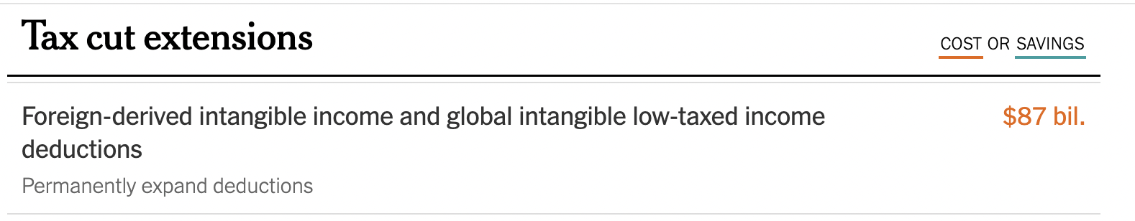

[New York Times, [6/30/2025](https://www.nytimes.com/interactive/2025/06/30/upshot/senate-republican-megabill.html)]

**The Megabill Permanently Extended The Discounted Tax Rate Paid By U.S. Multinationals On Foreign Profits–Global Intangible Low-Taxed Income.** “Among the corporate tax provisions included in the Ways and Means Committee’s draft bill are permanent extensions of the discounted tax rate paid by U.S. multinationals on foreign profits (Global Intangible Low-Taxed Income, or GILTI) and profits from export sales (Foreign-Derived Intangible Income, or FDII). These discounted tax rates cost the U.S. Treasury tens of billions of dollars annually, and substantially incentivize large corporations to shift profits and manufacturing facilities offshore. All together, the Joint Committee on Taxation estimates that extending these provisions represents a more than $170 billion tax break for major multinationals over the next ten years, though recent research from Penn Wharton suggests that the cost could be more than twice that.” [FACT Coalition, [5/13/2025](https://thefactcoalition.org/house-tax-package-corporate-tax-breaks-2025/)]

**The FDII And GILTI Effective Tax Rates Were Set To Rise In 2026, But The New Tax Bill Extends The Lower International Rates Permanently.** “Under current law, TCJA provisions will expire on December 31, 2025, and effective tax rates on FDII, GILTI, and BEAT rise in 2026. H.R. 1 generally—with small adjustments—extends the lower international rates permanently, which costs the federal government revenue. As shown below, H.R. 1’s changes to the current international tax regime are limited in their scope, with marginal across-the-board increases for the above provisions.” [Bipartisan Policy Center, [6/16/2025](https://bipartisanpolicy.org/explainer/how-does-the-2025-house-gop-tax-bill-change-international-tax-rules/)]

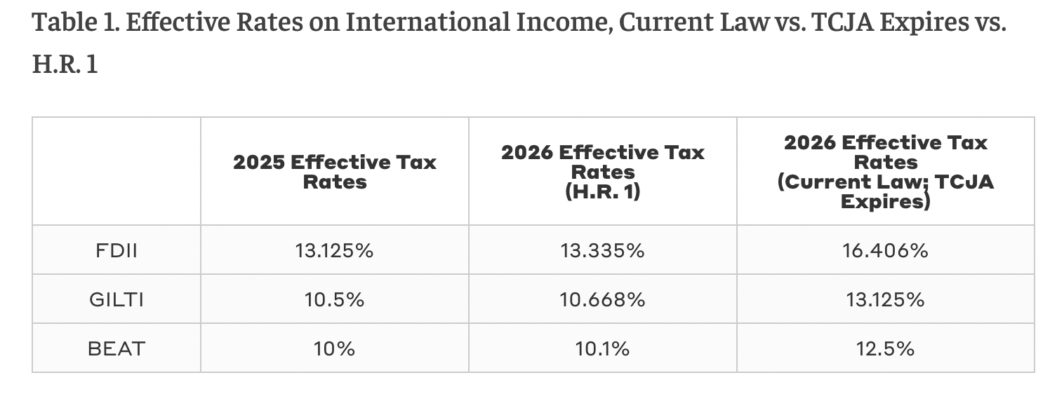

[Bipartisan Policy Center, [6/16/2025](https://bipartisanpolicy.org/explainer/how-does-the-2025-house-gop-tax-bill-change-international-tax-rules/)]

### THE FDII DEDUCTION WAS A HANDOUT TO BIG TECH

##### THE FDII DEDUCTION WAS A HUGE TAX BREAK FOR CORPORATIONS THAT EARN INCOME FROM THEIR INTELLECTUAL PROPERTY BY SELLING GOODS ABROAD, LIKE BIG TECH

**According To The FACT Coalition, The Foreign-Derived Intangible Income Deduction Was “A Massive Tax Break For Corporations That Earn Income From Their U.S. Intellectual Property By Selling Goods And Services Abroad.** “The 2017 tax reform massively reshaped how U.S. multinationals are taxed on their foreign income, including through the application of a global minimum tax that grants corporations a substantial discount on their foreign profits. This discount gave big multinationals new incentives to stash their most valuable intangible assets – intellectual property like patents, trademarks, and other highly mobile properties – in foreign tax havens to avoid taxation at the full U.S. domestic rate. In an attempt to balance this perverse incentive, the 2017 law sought to bring investment back to the United States through a provision known as the Foreign-Derived Intangible Income (FDII) deduction, a massive tax break for corporations that earn income from their U.S. intellectual property by selling goods and services abroad.” [FACT Coalition, [6/10/2024](https://thefactcoalition.org/fact-sheet-congress-should-repeal-a-wasteful-tax-break-for-big-tech/)]

**The Benefits Of FDII Primarily Flowed To Industries That Are Heavily Reliant On Intangible Assets Like Tech.** “FDII is problematic for many reasons. The tax break disproportionately benefits large corporations with significant intellectual property portfolios while doing little for smaller firms that lack similar assets. It also creates an incentive to shift investments overseas to exploit the lower tax rate. And the benefits of FDII primarily flow to industries that are heavily reliant on intangible assets, like tech and pharmaceuticals, thereby creating a tax code that treats different sectors of the economy much differently.” [Institute on Taxation and Economic Policy, [10/10/2024](https://itep.org/corporate-tax-avoidance-trump-tax-cut-fdii/)]

**According To The FACT Coalition, FDII Was A Major Reason Big Tech Firms Paid So Much Less Than The Statutory Corporate Tax Rate On U.S. Income.** “According to analysis by the Institute on Taxation and Economic Policy, from 2018 to 2023 just ten companies (Alphabet, Meta, Microsoft, Intel, Amazon, Qualcomm, Texas Instruments, Nvidia, Cisco Systems, and Apple) reported nearly $44 billion of combined tax benefit from FDII – almost 60% of the total benefit reported by all Fortune 1000 companies. This trend is not slowing down. Just five of these companies (Cisco, Google, Microsoft, Meta, and Amazon) received a combined tax benefit of $9.5 billion from FDII in 2023 alone. FDII is a major reason Big Tech firms pay so much less than the statutory corporate tax rate on U.S. income.” [FACT Coalition, [6/10/2024](https://thefactcoalition.org/fact-sheet-congress-should-repeal-a-wasteful-tax-break-for-big-tech/)]

##### BIG TECH COMPANIES INCLUDING ALPHABET AND AMAZON CASHED IN BILLIONS IN TAX BREAKS FROM THE FDII DEDUCTION

**From 2018 To 2023, Alphabet Was The Largest Beneficiary Of The FDII Deduction, Reporting $11 Billion In Tax Breaks, With Amazon Also Reporting More Than $1 Billion In Tax Breaks.** “One of the tax cuts included in former President Trump’s signature 2017 tax law was the deduction for Foreign-Derived Intangible Income (FDII). The FDII deduction provides a lower effective tax rate on income earned from intangible assets, such as patents, trademarks, and other forms of intellectual property. To contain the costs of the original tax law, the FDII rate was set to rise in 2026 but still not to the full 21 percent corporate tax rate. But lawmakers should consider abandoning the FDII break entirely. Corporate financial data analyzed by ITEP shows that many large, multinational corporations have benefited substantially from the FDII break. Since the law went into effect in 2018, 15 corporations have separately reported more than $1 billion in tax benefits. Alphabet (the parent company of Google) reported the most, at more than $11 billion in tax breaks from 2018 to 2023. Other beneficiaries include large tech firms such as Meta, Microsoft, Intel, and Qualcomm. The tech industry is not alone in benefiting from this tax break. Amazon, Nike, McDonald’s, and several pharmaceutical companies also reported more than $1 billion in tax breaks over this period. And because companies are not required to disclose this information, there could be many more.” [Institute on Taxation and Economic Policy, [10/10/2024](https://itep.org/corporate-tax-avoidance-trump-tax-cut-fdii/)]

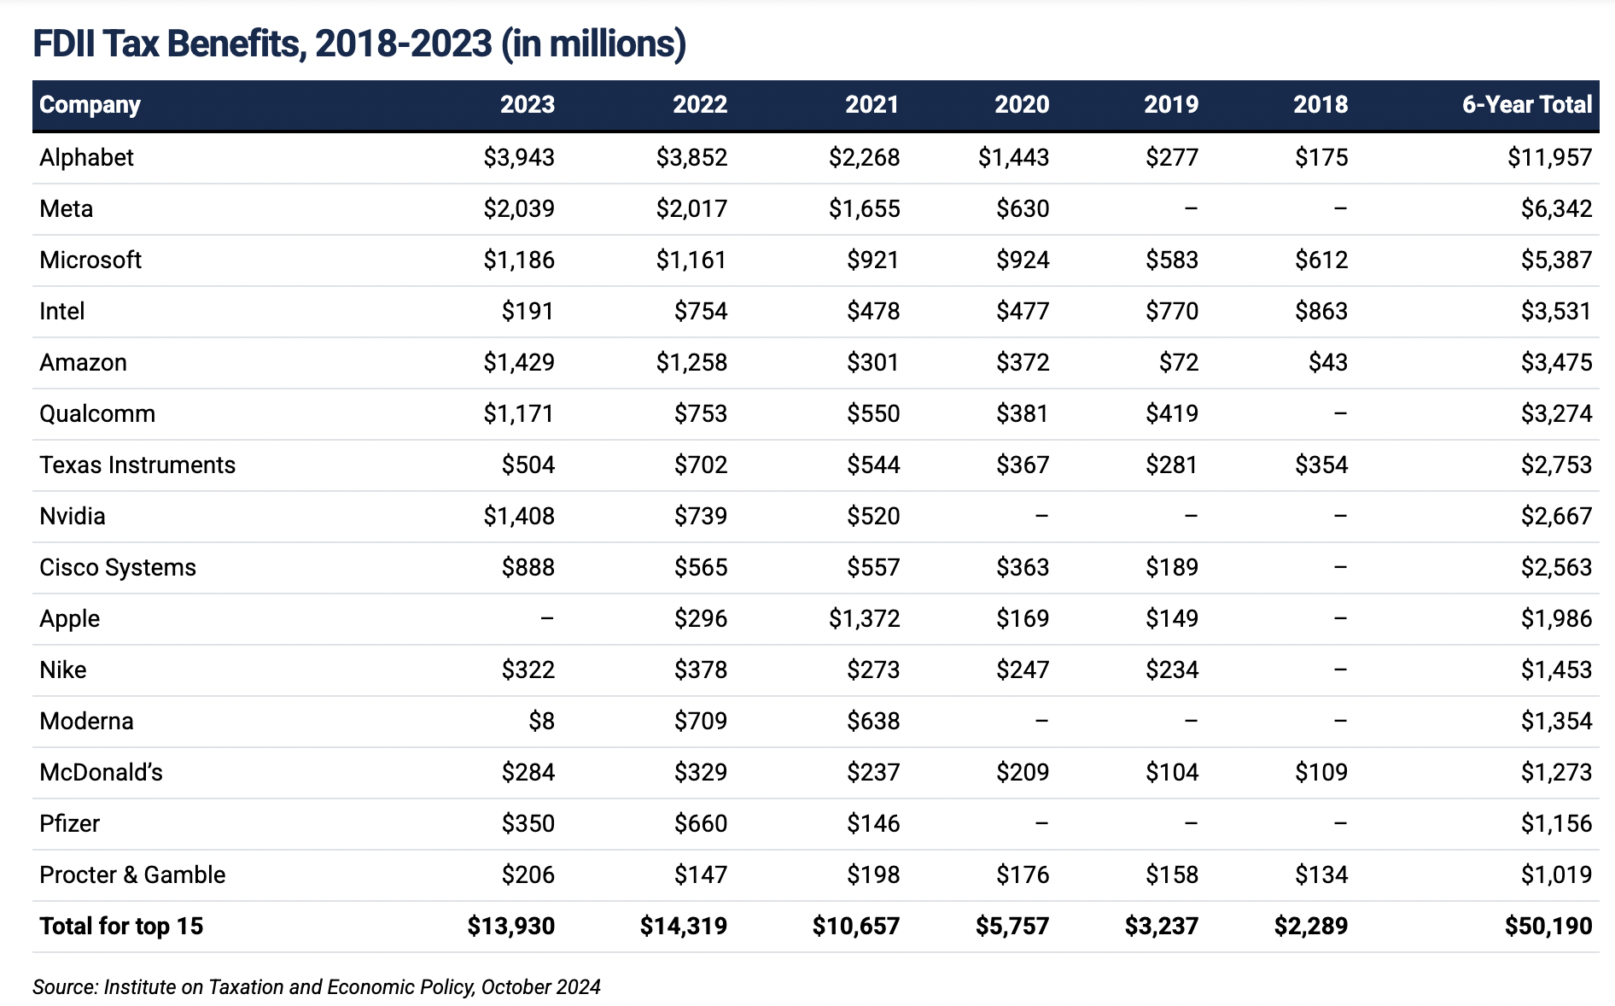

[Institute on Taxation and Economic Policy, [10/10/2024](https://itep.org/corporate-tax-avoidance-trump-tax-cut-fdii/)]

##### BIG TECH TRADE GROUPS PUSHED FOR THE PROTECTION OF THE FDII DEDUCTION

**The Information Technology Industry Council Pushed For The Protection Of The Foreign-Derived Intangible Income Deduction.** “Prior to the TCJA, there were several bipartisan proposals to create an incentive to retain U.S.-held IP and to domesticate foreign-held IP. Senators Schumer and Portman worked on an IP incentive, the Camp draft contained a new tax on intangible profits, and then-House Ways and Means Chair Neal had proposed an IP box. The Foreign Derived Intangible Income (FDII) regime achieved the goals of previous bipartisan proposals. As a result of the implementation of FDII, many U.S. multinationals – including a number of ITI member companies – have brought their IP back to the U.S. from other global locations. This change has given the U.S. the first right to tax this income, and it has encouraged the creation of further jobs and investment in the U.S. Additionally, this solidifies their R&D and innovative investments in the U.S. and increases the U.S. tax base. FDII allows the U.S. to be competitive because several other nations already offer IP incentives. FDII reflects a bipartisan consensus, and ITI opposes proposals to repeal FDII. Moreover, the U.S. government needs to defend and protect the effectiveness of FDII abroad, including in the OECD where some parties have challenged the policy at the Forum on Harmful Tax Practices, unfairly misunderstanding the combined policy goals of pairing GILTI with FDII to achieve greater neutrality in incentives where to locate IP. Per the TCJA, FDII is eligible for a deduction of 37.5% which results in a 13.125% rate for taxable years beginning after December 31, 2017, through taxable years beginning before January 1, 2026. For taxable years beginning after December 31, 2025, the deduction declines to 21.875% which results in a rate of 16.406%. It is essential that the FDII rate remains as low as possible.” [Information Technology Industry Council, [10/15/2024](https://www.itic.org/documents/tax/ITITAXTEAMSFINALLETTER_signature.pdf)]

* **The Information Technology Industry Council’s Members Included Amazon, Apple, Google, And Meta.** [Information Technology Industry Council, accessed [8/11/22](https://www.itic.org/about/membership/iti-members)]

### THE GILTI DEDUCTION WAS A HANDOUT TO BIG TECH

##### THE GILTI TAX APPLIED TO INCOME EARNED FROM “INTANGIBLE ASSETS” LIKE IP

**The GILTI Tax Applied To Income Earned From “Intangible Assets” Like IP.** “The global intangible low-taxed income (GILTI) tax applies to U.S. companies that own more than 50% of a foreign corporation and individual shareholders who own more than 10% of any stock in that corporation. GILTI aims at income earned from ‘intangible assets’ such as copyrights, patents, licenses, trademarks, and other intellectual property (IP).” [Reuters, accessed [7/8/2025](https://tax.thomsonreuters.com/en/glossary/global-intangible-low-taxed-income)]

##### BIG TECH TRADE GROUPS PUSHED FOR CONGRESS NOT TO RAISE THE GILTI TAX RATE

**The Information Technology Industry Council Advocated For Congress To Cancel The Scheduled Rate Increase For Global Intangible Low-Taxed Income.** “The Global Intangible Low-Taxed Income (GILTI) is currently taxed income but receives a 50% deduction resulting in a 10.5% rate for tax years beginning after December 1, 2017, through tax years beginning January 1, 2025. Foreign tax credits are allowed for 80% of taxes paid, resulting in a corresponding effective tax rate of 13.125%. Beginning in tax years after December 31, 2025, the deduction falls to 37.5% and the rate increases to 13.125%, which means an effective tax rate of 16.406% with the 80% haircut for foreign tax credits. To maintain U.S. competitiveness, Congress should cancel the scheduled rate increase for 2026 and look to reducing or eliminating altogether the 20% haircut on taxes paid in other jurisdictions. Maintaining parity between the rates for GILTI and FDII is essential to providing incentives for keeping current IP as well as future IP development in the U.S. Further, Congress should preserve the ‘aggregate’ approach for calculating GILTI – as opposed to taking a country-by-country approach – because it reflects the integrated nature of the foreign operations of companies, reduces the complexity of the GILTI calculation, and helps, in part, to mitigate the distortions caused by GILTI’s incorporation of foreign tax credits. Furthermore, the U.S. and global tax laws in general acknowledge that taxpayers can experience year to year volatility in earnings and have allowed carryovers (e.g., NOLs, FTCs, GILTI, etc.); however, this is a snapshot in time that does not allow carryovers. The blended global rate provides ‘rough justice’ by averaging across a global footprint because earnings volatility may not hit countries at the same time. Making GILTI more restrictive would turn it into a penalty tax, not a minimum tax as intended.” [Information Technology Innovation Council, [10/15/2024](https://www.itic.org/documents/tax/ITITAXTEAMSFINALLETTER_signature.pdf)]

* **The Information Technology Industry Council’s Members Included Amazon, Apple, Google, And Meta.** [Information Technology Industry Council, accessed [8/11/22](https://www.itic.org/about/membership/iti-members)]

## THE TAX BILL REDUCED THE BASE EROSION AND ANTI-ABUSE TAX, A KEY PRIORITY FOR BIG TECH

### THE TAX BILL REDUCED THE BASE EROSION AND ANTI-ABUSE TAX (BEAT), WHICH WAS DESIGNED TO CURB ARTIFICIAL PROFIT SHARING ARRANGEMENTS

**The Base Erosion And Anti-Abuse Tax Was Designed To Curb Artificial Profit Shifting Arrangements.** “The TCJA introduced the Base Erosion and Anti-Abuse Tax (BEAT) to curb artificial profit shifting arrangements. BEAT imposes a minimum tax on a modified taxable income base that includes certain ‘base erosion payments’, effectively treating these payments as taxable income. The BEAT is essentially a minimum tax of 10% on the sum of taxable income and base erosion payments made by companies with average annual gross receipts of $500 million or greater over three years and with deductions attributable to outbound payments greater than 3% of overall deductions.” [Information Technology Innovation Council, [10/15/2024](https://www.itic.org/documents/tax/ITITAXTEAMSFINALLETTER_signature.pdf)]

**The Senate Megabill Reduced BEAT.**

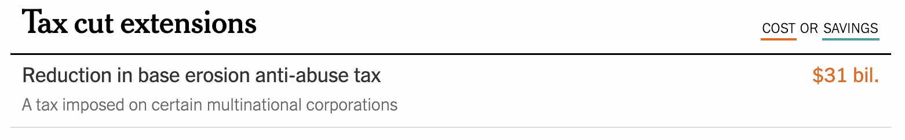

[New York Times, [6/30/2025](https://www.nytimes.com/interactive/2025/06/30/upshot/senate-republican-megabill.html)]

### BIG TECH LOBBYING GROUPS PUSHED FOR BEAT TO BE REDUCED, CALLING IT A PUNISHMENT FOR R&D COSTS

**The Information Technology Innovation Council Argued That BEAT “Punishes Companies For Deducting Domestic Research And Development (R&D) Costs.”** “BEAT also punishes companies for deducting domestic research and development (R&D) costs, primarily composed of wages, making the U.S. less competitive compared to other markets. Further, the BEAT disallows all or a portion of many commonly used tax credits from its computation, such as foreign tax credits, energy tax credits, and the low-income housing tax credit. The BEAT rate is scheduled to increase to 12.5% after December 31, 2025. In 2026 all credits will be completely disallowed, including the Section 41 R&D tax credit, disincentivizing important economic activity and subjecting companies to double taxation.” [Information Technology Innovation Council, [10/15/2024](https://www.itic.org/documents/tax/ITITAXTEAMSFINALLETTER_signature.pdf)]

* **The Information Technology Industry Council’s Members Included Amazon, Apple, Google, And Meta.** [Information Technology Industry Council, accessed [8/11/22](https://www.itic.org/about/membership/iti-members)]

**The Information Technology Innovation Council Argued That BEAT Should Be Reduced.** “ITI believes that BEAT unnecessarily targets Congressionally enacted incentives for innovative activities, particularly domestic R&D, and the exploitation of U.S. intellectual property. To retain the competitiveness of the United States as the best country for innovation, jobs, and investment, ITI asks that as a part of the discussion on taxes in 2025, Congress consider refining BEAT to: (1) excluding payments made to a foreign related party that are subject to a sufficient effective rate of foreign tax (15% or higher), (2) allow all tax credits to count against BEAT tax liability, (3) eliminate from the BEAT calculation all related party payments which do not erode the U.S. tax base, including payments that give rise to tested income under the GILTI regime or subpart F regime, and (4) suspend the currently scheduled 2026 BEAT tax rate increase.” [Information Technology Innovation Council, [10/15/2024](https://www.itic.org/documents/tax/ITITAXTEAMSFINALLETTER_signature.pdf)]

## BIG TECH COMPANIES STOOD TO GAIN FROM THE MASSIVE AMOUNTS OF NEW FUNDING FOR ICE

### THE TAX BILL TRIPLED THE BUDGET FOR CUSTOMS AND BORDER PROTECTION TO MORE THAN $60 BILLION

**The Megabill Would Nearly Triple The Budget For US Customs And Border Protection To More Than $60 Billion, Resulting In Bigger Contracts To Surveillance Tech Corporations.** “This budget reveals the intersection at which the anti-immigrant Right and the tech Right converge. Under the version of the bill headed to the president’s desk, US Customs and Border Protection's (CBP) 2024 budget of $23 billion would nearly triple. Some portion of this supplemental funding, which is estimated to exceed $60 billion, would result in bigger contracts to surveillance technology corporations. An additional $2.8 billion is allocated for ‘other surveillance technologies’ along the southwest, northern, and maritime borders. This may include an expansion of the ‘surveillance towers’ operated by Anduril Industries. Anduril was founded by Trump supporter Palmer Luckey, who has raked in billions of dollars worth of contracts since Trump took office.” [TechPolicy.Press, [7/3/2025](https://www.techpolicy.press/how-trumps-budget-bill-sells-out-the-future-to-big-tech/)]

### AMAZON RECEIVED MAJOR GOVERNMENT CONTRACTS FROM ICE FOR ITS CLOUD PLATFORM

**Amazon’s Cloud Services Undergirded Tech Platforms Used By ICE.** The report, commissioned by activist organizations Mijente, the National Immigration Project, and the Immigrant Defense Project, found that Amazon has played as central a role as Palantir in providing the backbone infrastructure for many of ICE’s, and DHS’s, key programs. Amazon has also enjoyed a cozy relationship with the federal government that has helped it secure an outsize number of government contracts. ‘What we’re starting to see more and more is that technology and technology contracts form a huge part of ICE’s budget and are also one of their critical tools for how they’re conducting enforcement on the ground,’ says Jacinta Gonzalez, the field director at Mijente.” [MIT Technology Review, [10/22/2018](https://www.technologyreview.com/2018/10/22/139639/amazon-is-the-invisible-backbone-behind-ices-immigration-crackdown/)]

**Palantir Paid Amazon $600,000 A Month For The Use Of Its Servers For Its Investigative Case Management (ICM) System, A Key Component Of ICE’s Deportation Operations.** “At the center of the criticism was data mining company Palantir, which designed the Investigative Case Management system. The ICM is a critical component of ICE’s deportation operations—it integrates a vast ecosystem of public and private data to track down immigrants and, in many cases, deport them. [...] In 2017, an Intercept investigation found that ICM pulled together data from an array of federal and private law enforcement entities to create detailed profiles that were then used to track immigrants. That data could include a person’s immigration history, family relationships, personal connections, addresses, phone records, biometric traits, and other information. All of that data and the algorithms powering ICM are now being migrated to Amazon Web Services (AWS) in their entirety; Palantir pays Amazon approximately $600,000 a month for the use of its servers, according to the report’s authors.” [MIT Technology Review, [10/22/2018](https://www.technologyreview.com/2018/10/22/139639/amazon-is-the-invisible-backbone-behind-ices-immigration-crackdown/)]

**Amazon Web Services Hosted Several Of DHS’s Major Immigration-Related Databases And Operations.** “Additionally, DHS was among the earliest agencies to adopt Amazon cloud services under Mark Schwartz, chief information officer at the US Citizenship and Immigration Service (USCIS). In 2017, after facilitating a major migration of one of DHS’s sub-agencies to AWS, Schwartz left the agency to become the enterprise strategist at that company. AWS did not respond to MIT Technology Review’s request to speak with Schwartz about his relationship with the company during his time in government. In addition to powering ICM, AWS hosts several of DHS’s other major immigration-related databases and operations, including all the core data systems for USCIS and biometric data for 230 million individuals, including fingerprints, face records, and iris scans, which are playing a growing role in immigration enforcement around the country.” [MIT Technology Review, [10/22/2018](https://www.technologyreview.com/2018/10/22/139639/amazon-is-the-invisible-backbone-behind-ices-immigration-crackdown/)]